The Title of Search: Z-GENERATION

Name: Hamid Obaidat
ID Number: 2021057333
Course Name: STAT 284

ABSTRACT:

We prepared this study about the Z-GENERATION to understand the profits, behaviors, and trends that characterize this age of the GEN. The Z-Generation includes people born between the 1995s to 2010s.
Another goal of this study was to understand the impact of digital technology, and to understand the social values and ideas that characterize this generation.

INTRODUCTION:

The Z-Generation includes people born between the 1995s to 2010s, and the people of this generation prefer to spend their time on electronics devices and internet instead of reading books.

LIT.REVIEW:

Anna Dolot [1] said that the youngest generation was born and grow in different situations than other generations, and she said there are five different generations are identified in the modern world; the traditionalists (born between 1928 and
- , the Baby Boomer Generation( born between 1945 and 1965),Generation X( born between 1965 and 1979),Generation Y( born between 1980 and 1995), and Generation Z(born after 1995 to 2017).

Zsuzsa [2] define various situations that make the generation. The author points out the characteristics of new generations focusing on the so-called Z generation.
Jeremy Goldman [3] found that the Generation Z is 25% less likely to use the search on google compared to Gen X, and 44% of Gen Z discover new brands on social media daily.
Minda Smiley [4] said that Gen Z is increasingly using Instagram, TikTok, and YouTube as search engines, and they are more likely to use social networks than search engines.

The Author [5] of this study said that generation z consists of individuals born between 1997 and 2012 who are presently 25 years old and younger. And the study shows that 95% of this generation owns or has access to a smartphone and almost all (97%) use the internet daily.

RESEARCH QUESTIONS:

- Understanding culture, behaviors, and social values ( gender, place of residence, estimate of students).
- How have education and careers evolved in the era of GENz.
- What is the role of youth in social participation politics.
- The extent of development of technological uses and means of communication.
- The extent of development of the health sector( gender, place of residence, estimate of students).

RESAARCH HYPOTHESIS :

- Is there a statistically significant relationship in understanding cultures , behaviors , and social values between males and females .
- Is there a statistically significant relationship in understanding cultures , behaviors , and social values in changing place of residence
- Is there a statistically significant relationship in understanding cultures , behaviors , and social values and student appreciation
- Is there a statistically significant relationship in understanding the extent of development of education and professions between males and females
- Is there a statistically significant relationship in understanding the extent of development of education and professions in change place of residence
- Is there a statistically significant relationship in understanding the extent of development of education and professions student appreciation
- Is there statistically significant relationship understanding the role of youth and social participation between males and females
- Is there statistically significant relationship understanding the role of youth and social participation in changing place of residence
- Is there statistically significant relationship understanding the role of youth and social participation in changing student appereciation.
- Is there statistically significant relationship of the use of technology between males and females
- Is there statistically significant relationship of the use of technology and place of residence
- Is there statistically significant relationship of the use of technology and student appereciation
13.Is there statistically significant relationship in understanding the development of the helath sector between males and females
14.Is there statistically significant relationship in understanding the development of the helath sector and place of residence
15.Is there statistically significant relationship in understanding the development of the helath sector and student appereciation.

SAMPLE AND POPULATION:

We chose the faculty of science to distribute the questionnaire which has students , 2613 and due to time constraints, our Dr asked to collect 73 questionnaires foe each group.

Population
2613
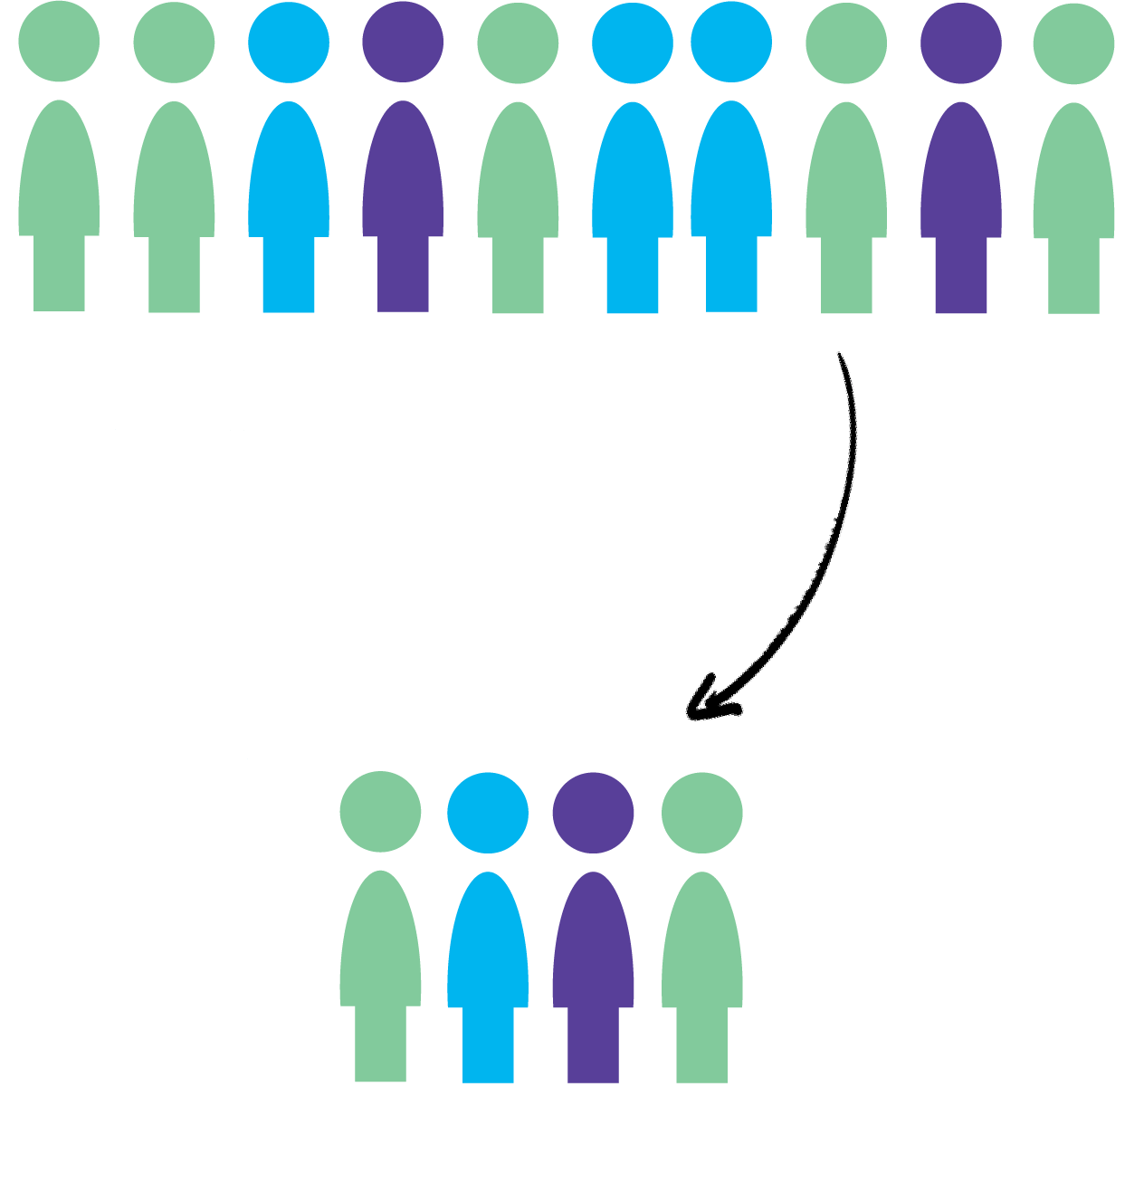
Sample
73

SAMPLE TECHNIQUE:

There are many techniques, and we chose the simple random sample, which is a type of probability sampling in which the researcher randomly selects a subset of participants from a population.

DATA ANALYIS:

A data analysis was coducted and we reached the results shown in the following table.
 | Valid percent | number | level | Variable
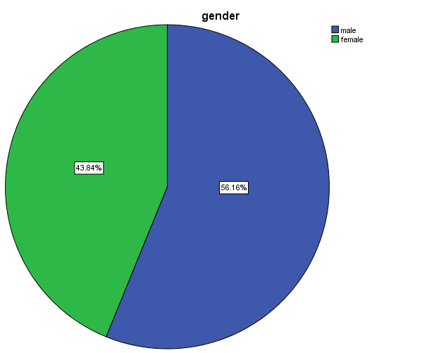 | 58.9% | 43 | male | Gender
 | 41.4% | 30 | female
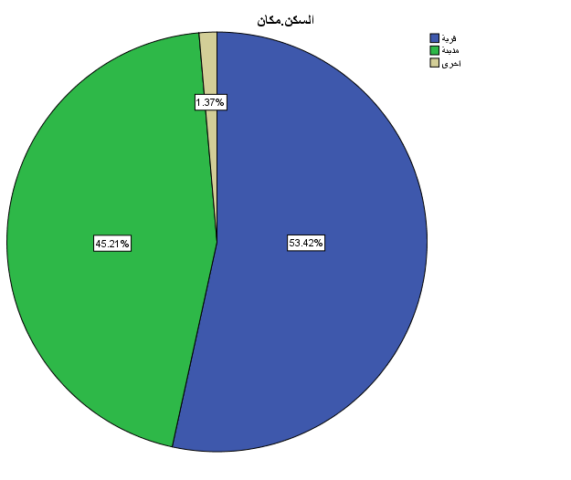 | 52.1% | 38 | Village | Place of residence
 | 46.6% | 34 | City
 | 1.4% | 1 | Other
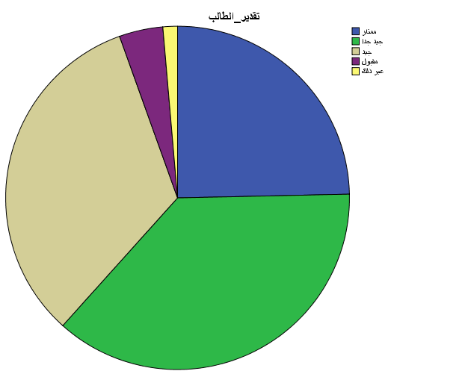 | 24.7% | 18 | Excellent
 | 37.0% | 27 | Very good
 | 32.0% | 24 | Good
 | 4.1% | 3 | Acceptable
 | 1.4% | 1 | other

DATA COLLECTION TOOL:

The study instrument was created and designed the first part is an indicative paragraph that is indicates the purpose of the study the second part ,where the study was conducted on gender , place of residence , and studant grade.

Validity :

The study tool was presented to two experts; Mohammad Obeidat , and
Mohammad Rawash . They edited some paragraphs:
(14 - 29) , (Others) , (Extent), (Considered), (Distinguished).

Descriptive statistic:
T_TEST one sample was uesed.
P_VALUE | T_test | Mean |  | Std.Deviaton | Number | Hypothesis
0 | -11.103 | 2.1145 | 0.68141 |  | 73 | H1
0 | -10.474 | 2.1347 | 0.70583 |  | 73 | H2
0 | -8.487 | 2.2443 | 0.76077 |  | 73 | H3
0 | -8.837 | 2.2694 | 0.70636 |  | 73 | H4
0 | -15.728 | 1.8836 | 0.60648 |  | 73 | H5

A Normal distribution test was conducted for the data and the result were found to be subject to a normal distribution one sample t test was used the result are shown in the following table.

INFERENTIAL STATISTICS:

The independent two test was used , and the result shown in the following table.
HYPOTHESES | Gender | Number | MEAN | ST | F | P
H1 | MALE | 43 | 2.0986 | 0.73052 | 1.646 | 0.813
 | FEMALE | 30 | 2.1373 | 0.61563
H2 | MALE | 43 | 2.1822 | 0.78748 | 1.305 | 0.257
 | FEMAL | 30 | 2.0667 | 0.57502
H3 | MALE | 43 | 2.2946 | 0.81717 | 1.608 | 0.503
 | FEMALE | 30 | 2.1722 | 0.67875
H4 | MALE | 43 | 2.3953 | 0.67065 | 0.094 | 0.068
 | FEMALE | 30 | 2.0889 | 0.72811
H5 | MALE | 43 | 1.9302 | 0.64574 | 0.345 | 0.435
 | FEMALE | 30 | 1.8167 | 0.54903

- The results of the analysis showed that the data are subject to normal distribution. The independent two test was used, and the test hypothesis was that there is a statistically significacnt relationship at the significance level of 0.05 to understand cultures, behaviors, and social values between males and females.The results showed that there is a relationship at the same significance level between male and female.

- The results of the analysis showed that the data are subject to normal distribution. The independent two test was used, and the test hypothesis was that there is a statistically significacnt relationship in understanding the extent of development of education and professions at a significance level of 0.05.
The results showed that there is a relationship at the same significance level between male and female.

- The results of the analysis showed that the data are subject to normal distribution. The independent two test was used, and the test hypothesis was that there is a statistically significacnt relationship in understanding the role of youth in politics and social participation.The results showed that there is a relationship at the same significance level between male and female.

- We conducted an independent two test and it turns out that the data is subject to a normal distribution. The test hypothesis was : Is there a statistically significant relationship in understanding the extent of development of technological uses and means of communication at a significance level of 0.05? . The results showed that there is a relationship.
- We conducted an independent two test and it turns out that the data is subject to a normal distribution. The test hypothesis was: Is there a statistically significant relationship in understanding the extent of health sector development between males and females?. The results showed that there is a relationship.
ANOVA TEST:

HYPOTHESES |  | Number | MEAN | ST | F | P
H1 | VILLAGE | 38 | 2.0232 | 0.54842 | 1.803 | .172
 | CITY | 34 | 2.2424 | 0.79134
 | OTHER | 1 | 1.2400 | -
H2 | VILLAGE | 38 | 2.0570 | 0.65791 | .791 | .458
 | CITY | 34 | 2.2353 | 0.76003
 | OTHER | 1 | 1.6667 | -
H3 | VILLAGE | 38 | 2.3465 | 0.80574 | .967 | .385
 | CITY | 34 | 2.1176 | 0.70774
 | OTHER | 1 | 2.6667 | -
H4 | VILLAGE | 38 | 2.2719 | 0.76073 | 1.180 | .313
 | CITY | 34 | 2.2353 | 0.63580
 | OTHER | 1 | 3.3333 | -
H5 | VILLAGE | 38 | 1.8904 | 0.62394 | 3.154 | .049
 | CITY | 34 | 1.8333 | 0.54742
 | OTHER | 1 | 3.3333 | -

H5 | EXELLENT | 18 | 1.9133 | 0.63724 | 2.023 | .101
 | VERY GOOD | 27 | 2.1037 | 0.77787
 | GOOD | 24 | 2.3667 | 0.53245
 | ACCEPTABLE | 3 | 1.6933 | 0.60044
 | OTHER | 1 | 1.2400 | -
H6 | EXELLENT | 18 | 2.0833 | 0.60025 | 1.042 | .392
 | VERY GOOD | 27 | 2.0062 | 0.65939
 | GOOD | 24 | 2.3542 | 9.83596
 | ACCEPTABLE | 3 | 2.0556 | 0.38490
 | OTHER | 1 | 1.5000 | -
H7 | EXELLENT | 18 | 2.0648 | 0.75221 | 1.199 | .319
 | VERY GOOD | 27 | 2.1358 | 0.82824
 | GOOD | 24 | 2.5069 | 0.69934
 | ACCEPTABLE | 3 | 2.3333 | 0.33333
 | OTHER | 1 | 1.8333 | -
H8 | EXELLENT | 18 | 2.1759 | 0.67270 | 1.841 | .131
 | VERY GOOD | 27 | 2.2037 | 0.67040
 | GOOD | 24 | 2.5208 | 0.75070
 | ACCEPTABLE | 3 | 1.5556 | 0.19245
 | OTHER | 1 | 1.8333 | -
H9 | EXELLENT | 18 | 1.8796 | 0.44209 | 1.299 | 0.279
 | VERY GOD | 27 | 2.0309 | 0.73094
 | GOOD | 24 | 1.8056 | 0.55748
 | ACCEPTABLE | 3 | 1.2778 | 0.34694
 | OTHER | 1 | 1.6667 | -

(H1 - H5)
- We conducted a normal distribution test for the data, and it turned out that it is subject to a normal distribution.The on-way ANOVA test was used, and the test hypothesis was: Is there a statistically significant relationship in understanding cultures,behaviors, and social values of the place of residence? It turned out that there is a relationship.
- We conducted a normal distribution test for the data, and it turned out that it is subject to a normal distribution.The on-way ANOVA test was used, and the test hypothesis was: Is there a statistically significant relationship in understanding the extent of development of education and professions to the place of residence at a significance level of 0.05? The result showed that there is a relationship.

- We conducted a normal distribution test for the data, and it turned out that it is subject to a normal distribution.The on-way ANOVA test was used, and the test hypothesis was: Is there a statistically significant relationship in understanding the role of youth in politics and social participation in the place of residence at a significance level of 0.05? .It was found that there is a relationship.
- We conducted a normal distribution test for the data, and it turned out that it is subject to a normal distribution.The on-way ANOVA test was used, and the test hypothesis was: Is there a statistically significant relationship in understanding the extent of the development of technological uses and means of communication for the place of residence at a significance level of 0.05?. The result showed that there is a relationship.
- We conducted a normal distribution test for the data, and it turned out that it is subject to a normal distribution.The on-way ANOVA test was used, and the test hypothesis was: Is there a statistically significant relationship in understanding the extent of the health sector to the place of residence?. It turned out that there is no relationship.

(H6 - H9):
- We conducted a normal distribution test for the data, and it turned out that it is subject to a normal distribution.The on-way ANOVA test was used, and the test hypothesis was: Is there a statistically significant relationship in understanding cultures,behaviors, and social values for the student’s estimate at a significance level of 0.05? . It turns out that there is a relationship.
- We conducted a normal distribution test for the data, and it turned out that it is subject to a normal distribution.The on-way ANOVA test was used, and the test hypothesis was: Is there a statistically significant relationship in understanding the extent of development of education and professions for student appreciation at a significance level of 0.05? It turns out that there is a relationship.
- We conducted a normal distribution test for the data, and it turned out that it is subject to a normal distribution.The on-way ANOVA test was used, and the test hypothesis was: Is there a statistically significant relationship in understanding the role of youth in politices and social paticipation for students estimate at a significance level 0.05 , it turend out that there is a relation ship
- We conducted a normal distribution test for the data, and it turned out that it is subject to a normal distribution.The on-way ANOVA test was used, and the test hypothesis was: Is there a statistically significant relationship in understanding the extant of the development of technological uses and means of communication for student estimate at a significance level of 0.05 it was found that there is a relationship.
- We conducted a normal distribution test for the data, and it turned out that it is subject to a normal distribution.The on-way ANOVA test was used, and the test hypothesis was: Is there a statistically significant relationship in understanding the extent development of the health sector to the student estimate at a significance level of 0.05 the results showed that there is a relationship.

REFERENCES:

[1] . Anna Dolot, The characteristic of Generation Z, “e-mentor” 2018, s. 44–50, http://dx.doi. org/10.15219/em74.1351.

- . Zsuzsa Emese Csobanka,The Z Generation , Acta Technologica Dubnicae volume 6, 2016, issue 2 .

- . Jeremy Goldman,Social media overtakes search engines for discovery among Gen Z, Jun 6, 2024.8.17.

[4] . Minda Smiley,Gen Z Social Search Habits,Feb 20, 2024

[5] . Rebecca C. Slepian, Haley Furman,Social media, wearables, telemedicine and digital health,—A Gen Y and Z perspective,Comprehensive Precision Medicine
Volume 1, 2024, Pages 524-544.

